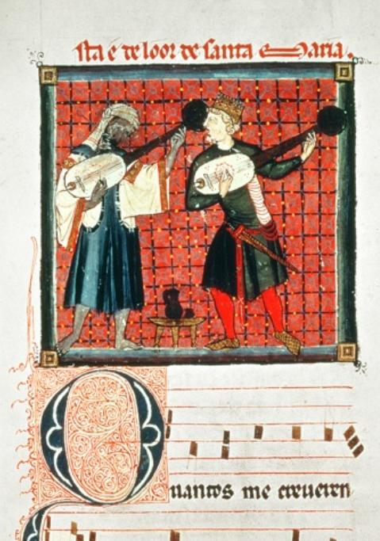

Friday 13th September 16:30-18:30
Why was Occitania such a fertile ground for the troubadours?
Can we discover the origins of troubadour philosophy?
Do Paratge and Fin’Amors constitute a new way of looking at the world?
Troubadours and The Tree of Life

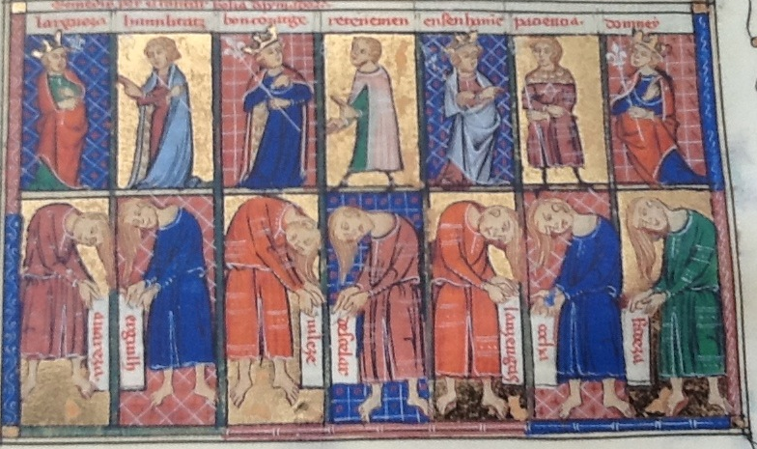

Saturday 14th 16:30-18:30
Lives of the troubadours and their music
Pretz e Paratge: A troubadour’s song of love, war, and transformation.

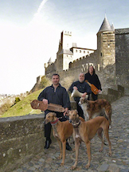

La Rosa Trobadoresca concert of troubadour music after dinner.

